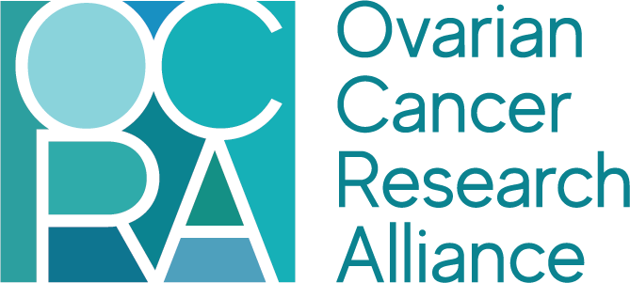

Advocate Leaders Manual
2026

Table of Contents
I. Welcome 3
II. About Ovarian Cancer Research Alliance 4
III. Why Advocacy? 5
IV. Advocate Leaders Program 7
a. Overview 7
b. Advocate Leaders’ Role 8
c. Responsibilities & Commitment 8
d. Committee Structure 9
e. Advocacy Day 10
V. Advocate Leaders Community 11
a. Basecamp 11
VI. Contacting OCRA Staffers 12

I. Welcome

Welcome to Ovarian Cancer Research Alliance’s Advocate Leaders program!
The Advocate Leaders program, formerly known as the Grasstops Program, was created in 2012. The program’s membership is comprised of patients, survivors, caregivers, and supporters from across the United States who support OCRA’s mission and want to make a difference and support the ovarian and gynecologic cancer community. Advocates’ primary goal is to build relationships with their elected government officials to enhance support for ovarian and gynecologic cancer policy issues and raise the profile of ovarian and gynecologic cancer.
This manual will serve as your guide to help you understand the program’s goals and structure, as well as your role and responsibilities as an Advocate Leader. The manual is a companion to the Advocacy Toolkit and the Resource Bank, which will provide you the necessary tools and best practices to execute your role as an Advocate Leader in your community. Throughout the year, OCRA staff will work with Advocate Leaders through conference calls, written materials, and skills-building workshops to help you get more comfortable with advocacy. In turn, you as Advocate Leaders will serve as a resource for OCRA as constituents and community members who understand the ovarian and gynecologic cancer community and are well-positioned to effect change.

II. About Ovarian Cancer Research Alliance

In 2016, the Ovarian Cancer Research Fund and the Ovarian Cancer National Alliance merged to form Ovarian Cancer Research Alliance (OCRA). Ovarian Cancer Research Alliance is the leading organization in the world fighting ovarian cancer from all fronts: in the lab, on Capitol Hill, and supporting those directly affected throughout.
As the largest non-government funder of ovarian cancer research, OCRA’s ongoing investments in the most promising scientific research are funding discoveries, creating new treatments, and hastening desperately needed breakthroughs. We are the voice for the ovarian cancer community, working with legislators to ensure federal ovarian cancer research and education, patient safety, and access to high-quality care are priorities on Capitol Hill. Our programs help people navigate their diagnosis and support patients and their families when and where they need it most.

III. Why Advocacy?

Advocacy is the practice of publicly supporting and working to enact a particular cause or policy and can take many forms. Anything from submitting a comment on a piece of proposed legislation, to tagging your representative in a passionate Facebook post, to raising awareness about how a policy affects your community – it’s all advocacy. Advocacy work is critical for advancing important causes and is a necessary part of policy making.
Every day, legislators make decisions about policies impacting everything from healthcare to foreign policy to social issues to financial regulations. No politician is an expert in all – or even most – of these areas, and they must make decisions about them in short time frames while considering competing priorities. They don’t have the time or capacity to drill down into how policies would impact each constituent – for example, how a healthcare regulation might affect an ovarian cancer patient versus a lung cancer patient.
Advocacy groups help fill in these gaps, providing policymakers and their staff with in-depth and personalized information about how the legislation they are considering would affect the advocacy groups’ community. This is where Advocate Leaders come in. With your personal connection to the issue, you have a unique perspective that can stick in lawmakers’ memories and ultimately shape their decisions – you make the issue real. You don’t need to have an in-depth understanding of the legislative process to be effective; you simply need passion, persistence, and a willingness to share your story.
Cancer is a non-partisan issue. This means that legislators’ willingness to engage with the issue is not delineated by party lines, and Democrats and Republicans work together to identify and advance policy solutions. Furthermore, ovarian and gynecologic cancer does not discriminate and impacts people of all political, socio-economic, and cultural backgrounds, meaning that any legislator could have a personal connection to the issue that motivates them to act. Support for bio-medical research is generally strong on either side of the political aisle, but there are significant funding disparities from cancer to cancer. Ovarian cancer is disproportionately underfunded relative to its lethality, so we have an opportunity to make a critical impact.
Since 2012, OCRA’s legislative advocacy has contributed to numerous policy wins for the ovarian cancer community. Some notable examples:
- Reauthorization of legislation originally signed by President Bush supporting gynecologic cancer education and awareness, known as Johanna’s Law
- The launch of the congressional Ovarian Cancer Caucus in 2015
- Funding increases for the Ovarian Cancer Research Program in the Department of Defense (from $20 million in 2019 to $45 million in 2024), and for ovarian cancer programs in the Centers for Disease Control (CDC), the Ovarian Cancer Control Initiative, and Johanna’s Law (from $17.5 million in 2019 to $27 million in 2023)
- Language in appropriations legislation directing the CDC to investigate and address the shortage of ovarian cancer clinical trials
- The defeat of repeated efforts to defund the Congressionally Directed Medical Research Program which funds the Ovarian Cancer Research Program at the Department of Defense, including the passage of a package of amendments to protect funding for this program on the Senate floor.

IV. Advocate Leaders Program

a. Overview
The Advocate Leaders program is managed by the following OCRA staff:
- Chad Ramsey, Vice President, Policy
- Julia Thayer, Associate Director, Advocacy
- Emily Rakos, Manager, Programs
Emily is the program’s first point of contact, so reach out to her with any questions, concerns, or suggestions regarding Advocate Leaders (see “V. Contacting OCRA Staffers” for details on how to reach Emily).
Advocate Leaders are selected at the end of each calendar year, and the new cohort assumes their AL roles in January of the following year. Advocate Leaders agree to commit to the program for a one-year term and can serve additional terms contingent on their interest and engagement.

Advocate Leader Map 2026
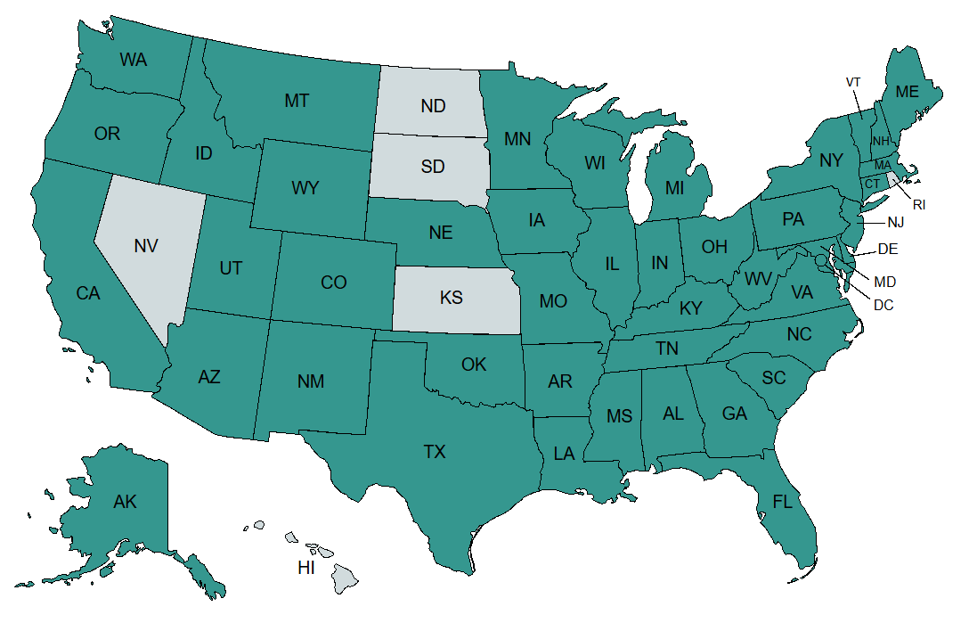

b. Advocate Leaders’ Role
Advocate Leaders’ primary role is as a constituent advocate. Therefore, OCRA asks our Advocate Leaders to develop and maintain relationships with their elected officials. There are several ways to build relationships with your legislators:
- In-person or online meetings with elected officials or their staff
- Tagging your elected officials on social media
- Inviting your elected officials to awareness and fundraising events that you’re hosting or participating in
- Thanking your elected officials when they take action that supports the ovarian cancer community, or holding them accountable when they don’t
- And more (see the Advocacy Toolkit and Resource Bank for more information on building relationships with elected officials)
ALs also serve as OCRA’s first point of contact for various advocacy-related tasks. These may include:
- Taking action on advocacy requests, such as contacting elected officials about legislation, urging your Members of Congress to sign a “Dear Colleague” letter, etc.
- Elevating ovarian and/or gynecologic cancer or related advocacy issues by writing op-eds or letters to the editor
- Organizing awareness or advocacy events
- Sharing personal stories to help inform policy changes for issues such as drug pricing, insurance coverage, oral parity, etc.
- Participating in state or local campaigns to benefit the ovarian cancer community
Advocate Leaders are key parts of our advocacy activity. We consider them to be grasstops community leaders for the ovarian and gynecologic cancer community. Though Advocate Leaders hold prestige in our organization, Advocate Leaders are not employees of Ovarian Cancer Research Alliance. However, we encourage you to identify yourself as an OCRA Advocate Leader.

c. Responsibilities & Commitment
Each Advocate Leader may fulfill their role differently based on their schedule, energy, and interests, but a few uniform expectations should be met to remain in the program:
- Participation in hour-long monthly conference calls with fellow ALs and OCRA staff
  - We understand that everyone will not be able to attend every call. When you are unable to attend a call, you must inform Emily before the call takes place. Repeated, unexplained absences from monthly calls may result in expulsion from the program.
- Follow through on OCRA’s calls to action
  - When important legislation is pending in Congress, we may call on you to urge your representatives and senators to vote a specific way. We will provide you with sample language and contact information and encourage you to personalize your messages based on your relationships with your elected officials and their staff.
- Completion of one awareness activity or event during September, National Ovarian Cancer Awareness Month
  - This can be anything from planning and hosting your own event to handing out symptom cards at local businesses to writing an op-ed or letter to the editor. Everyone’s contribution will be unique, but everyone must take some action to further awareness in September.
- Attendance at OCRA’s Spring Advocacy Day, typically held in March
  - Advocacy Day can happen either virtually or in-person in Washington, D.C. In 2026, Spring Advocacy Day will be hosted in person.

e. Advocacy Day
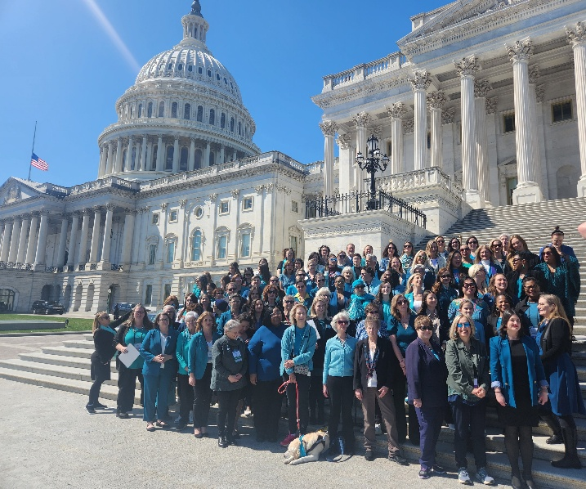
OCRA’s annual Advocacy Day is the centerpiece of the Advocate Leaders program. Advocate Leaders and other ovarian and gynecologic cancer advocates from all over the country travel to Capitol Hill, when held in-person, or take to Zoom when online to meet with their legislators’ offices and advocate for policies that affect the ovarian and gynecologic cancer community. These meetings are critical for building relationships with congressional offices and personalizing OCRA’s policy asks.
Prior to Advocacy Day, OCRA will offer comprehensive training to prepare advocates for their Hill meetings. The training details OCRA’s policy asks (funding for programs, support for legislation regarding related issues, etc.), gives an overview of how Hill meetings usually run, primes participants on how to elevate their advocacy via social media, and more.
On Advocacy Day, advocates will meet with their senators’ and representatives’ offices throughout the day. Participants may be in groups as large as fifteen, or as small as two. Advocates may attend their meetings alone if they feel comfortable doing so, but generally it’s a good idea for first timers to attend their meetings with at least one other person. OCRA will provide each advocate a schedule of their meeting times, points of contact, and office numbers, and staff will be available for additional assistance.
After advocates finish their Hill meetings, they may report back to OCRA about how the meetings went, whether the staff or legislators signaled support, and whether they requested any follow-up information. Additionally, advocates are encouraged to send thank-you notes to the offices they met with to continue the relationship-building they began in their meetings.
In 2026, OCRA will host their annual Spring Advocacy Day in person in Washington, DC from March 15-17.

V. Advocate Leaders Community

Advocate Leaders are not only building relationships with their elected officials, but with one another and with OCRA staff. Advocacy can be at times both rewarding and frustrating, and a sense of community with your fellow ALs and OCRA staff helps to fight fatigue and gives you people to celebrate with. To help you begin these relationships, OCRA provides you with a member directory of all Advocate Leaders. You can use the directory, Basecamp posts (see the next section for more details on Basecamp), monthly calls, and events like Advocacy Day and OCRA’s International Gynecologic Cancer Conference to develop relationships with your fellow Advocates.


a. Basecamp

Advocate Leaders and OCRA staff communicate via Basecamp, an online communication forum, to share resources, update one another on outreach and advocacy efforts, and provide logistical and emotional support.
If you are unsure about whether something can or should be posted to Basecamp, a general rule of thumb is that if other ALs could benefit from your question or comment then you should post it. For example, sharing an ovarian cancer-related article or webinar, sharing a new resource, or celebrating a local accomplishment. On the other hand, if your question or comment relates to you specifically, it’s better to email OCRA staff directly. For example, notifying Emily when you will not be on a monthly call, indicating that you’ve completed a request from OCRA staffers, or inquiring about an advocacy scenario specific to your district or state.
You’ll receive an email notification every time someone starts a new discussion thread or posts a comment, so it’s not necessary to monitor Basecamp via the website. There are additional training resources on how to use Basecamp available as part of the Resource Bank.

VI. Contacting OCRA Staffers

OCRA staff are in regular communication with ALs through our monthly conference calls, but if anything comes up in between there are several ways to reach us.
The best way to reach out to OCRA staff is via email, which is preferable to phone calls because of the ease of responding. If you have reached out and sent a reminder email and still have not gotten a response, a direct call is the best approach.
We don’t recommend trying to contact OCRA staff through Basecamp. A request made through Basecamp is not guaranteed to yield a response from OCRA.
Emily is the first point of contact for the program; please reach out to her first, and if necessary, she will direct your communication to someone else on the team.
Contact information for OCRA Policy staffers is below:

Chad Ramsey, Vice President, Policy: cramsey@ocrahope.org, (202) 517-6404

Julia Thayer, Associate Director, Advocacy: jthayer@ocrahope.org, (202) 517-6405

Emily Rakos, Manager, Programs: erakos@ocrahope.org, (646) 768-0179

